**PROMOTION ENGINE**

**TABLE STRUCTURE AND DETAILS:**

1. Table Name: SKU

|  |  |
| --- | --- |
| **Field** | **Type** |
| prod_name | varchar(2) |
| quantity | int(11) |
| prod_type | varchar(2) |
| prod_no | int(11) |
| amount | Float |
| dis_amt | Float |

Table Description : Table contains discount details with respect to specific product.

Table Field Description:

* Prod_name : Contains name of the product
* Quantity : Contains quantity on which discount is applicable
* Prod_type : Contains type of Product discount. Value to be kept as ‘S’ if discount is on single product and for multiple quantity and any value can be assigned if discount is on the basis of combination.
* Prod_no : Contains item number.
* Amount : Contains original price of the product.
* Dis_amt : Contains discounted price of the product.

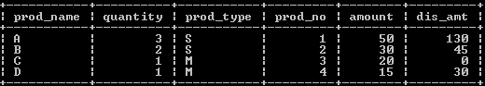

1. Table Name : ORDERS

|  |  |
| --- | --- |
| **Field** | **Type** |
| prod_no | int(11) |
| prod_name | varchar(2) |
| quaantity | int(11) |
| seq_no | mediumtext |

Table Description : Table contains details of orders.

Table Field Description:

* Prod_no : Contains item number.
* Prod_name : Contains name of the product
* Quaantity : Contains quantity of product.
* Seq_no : Contains Invoice number of the product.

**SCENARIO A:**

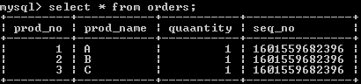

Input :

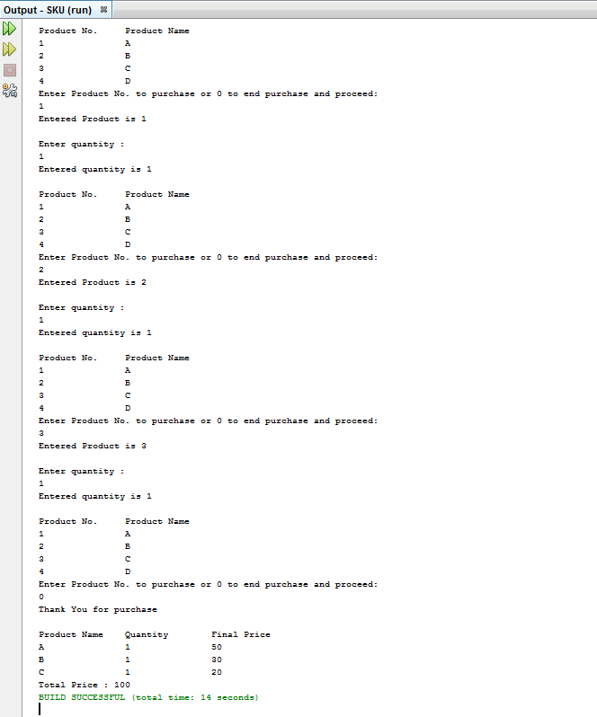

**SCENARIO B:**

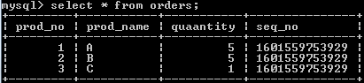

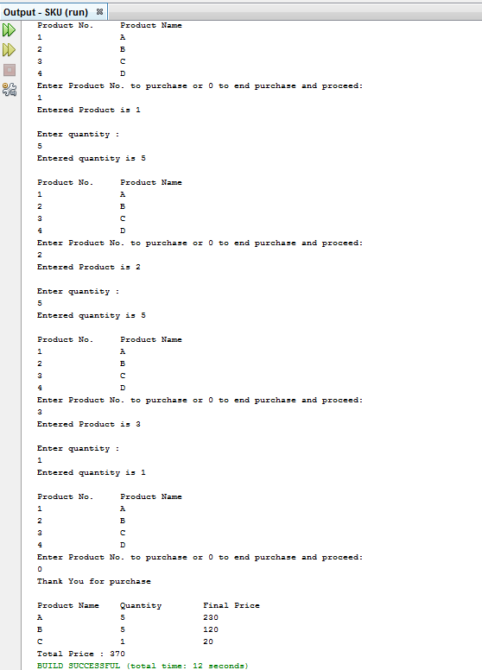

**SCENARIO C :**

